73.04.02a
From J. 0'Driscoll
I73/9284, unit 750, VPRS 44/P inward registered and unregistered correspondence, VA 538 Department of Crown Lands and Survey, Public Record Office, Victoria.

Baron Von Mueller
The undersigned presents his compliments to Baron Von Müeller and would feel greatly obliged if he would grant about 150 trees and shrubs for planting the Roman Catholic Church grounds at Emerald Hill.
J. O'Driscoll
R.C.C.

St. Peter & Paul's
Emerald Hill
April 2nd 1873

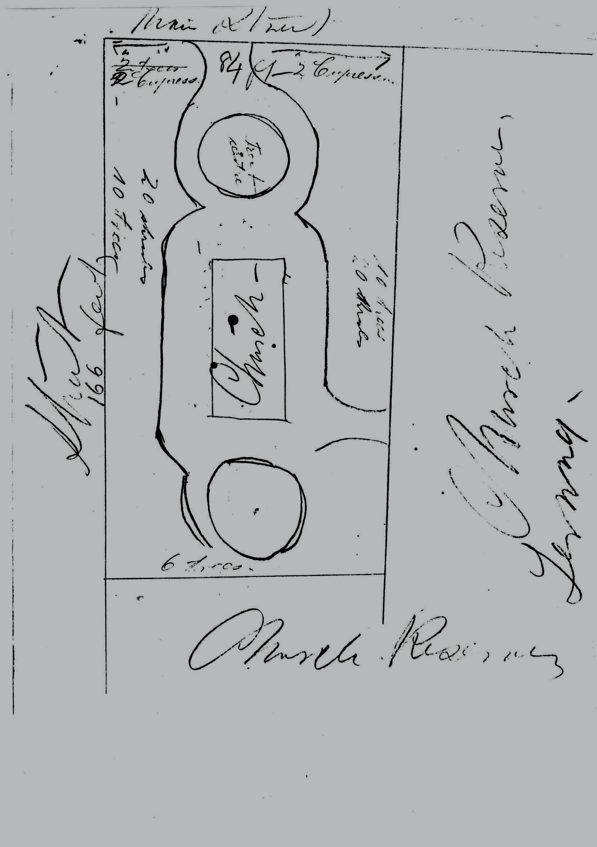

MS is accompanied by a pencil sketch map in an unknown hand showing the dimensions of the Church and grounds. 73-04-02a_image01.jpg It includes suggested numbers of shrubs and trees required for planting in the positions shown. See also M to J. Casey, 22 May 1873 (in this edition as 73-05-22q).
Now South Melbourne.

